**SHIMONI DEMONSTRATION SCHOOL-KIRA**

**MID TERM TWO EXAMINATIONS, 2024**

**P.6 INTEGRATED SCIENCE**

NAME__________________________________________________________

***SECTION A***

1. State one characteristic of a bean plant that makes it a living thing.

________________________________________________________________________

2. Give any one way of preserving milk.

________________________________________________________________________

3. Name any one example reptile.

________________________________________________________________________

4. Give any one example of spore producing plants.

________________________________________________________________________

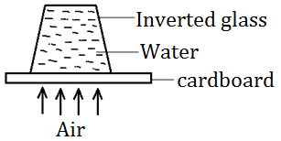5. Which property of air is represented in the illustration below?

________________________________________________________________________

6. Name the type of soil which does not allow water too pass through it easily.

________________________________________________________________________

7. What is the duty of a queen bee in a hive?

________________________________________________________________________

8. What are vertebrates?

________________________________________________________________________

________________________________________________________________________

9. How are scavenger birds useful to man?

________________________________________________________________________

10. Name the skeleton disease prevented by administering BCG vaccine.

________________________________________________________________________

11. Calculate the density of a stone whose mass is 160g and has displaced water equal to 40cc.

12. Which part of the clinical thermometer has a similar function with valves of mammalian heart?

________________________________________________________________________

13. What is an echo?

________________________________________________________________________

________________________________________________________________________

14. **The diagram below shows a beak. Study it carefully and answer questions**.

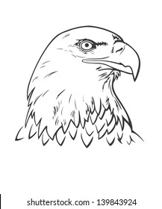

Identify the type of food which a bird with the above beak feeds on.

______________________________________________________________________________________________________________________________

15. How is the plant below adapted to being dispersed by animals?

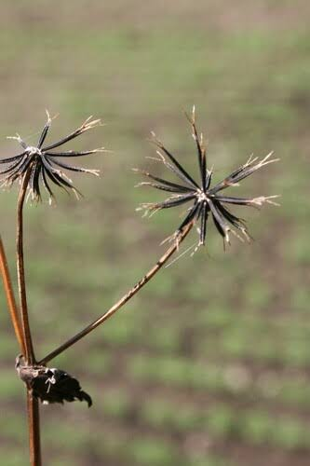_____________________________________________________

16. Give one material used when harvesting honey.

________________________________________________________________________

17. How can we reduce the speed of fasting running water in the school compound?

________________________________________________________________________

18. Mention any one disease which is likely to break out in case of poor hygiene in a

community.

________________________________________________________________________

19. Name the part of an insect that has the same function as the gills of the fish.

________________________________________________________________________

20. Apart from animal kingdom, which other group of organism make up living things?

________________________________________________________________________

21. Kato suffered from a disease and recovered, which type of immunity did he get?

________________________________________________________________________

22. State one reason why animals make sound.

________________________________________________________________________

23. Give one example of flightless bird.

________________________________________________________________________

24. What is seed dispersal?

________________________________________________________________________

________________________________________________________________________

25. Which part of the human ear maintains body posture?

_________________________________________________________________________

_________________________________________________________________________

26. Name the farm practice that makes mating easy in sheep.

________________________________________________________________________

27. Write one danger of sharing a water source with animals.

________________________________________________________________________

28. Give one characteristic which is common in all mammals.

________________________________________________________________________

29. How do fish help in the control of malaria?

________________________________________________________________________

30. How can a farmer control weeds in the garden?

________________________________________________________________________

31. What is the importance of ventilators on a living house?

________________________________________________________________________

32. Name the part of the flowering plant marked “X” in the diagram below.

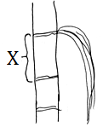

X ___________________________________

33. What is frequency as used in science?

________________________________________________________________________

34. What practice enables a primary child to remove germs from his/her hands after using a latrine?

________________________________________________________________________

35. What name is given to the main artery?

________________________________________________________________________

________________________________________________________________________

36. Why does blood go to the lungs?

________________________________________________________________________

37. In which part of the maize grain is the food stored?

________________________________________________________________________

38. How is sound produced?

________________________________________________________________________________________________________________________________________

39. Name one example of a fruit that develop from the receptacle of a flower.

________________________________________________________________________

40. Change 320F to Celsius scale.

***SECTION B***

41. (a) What is pollination?

________________________________________________________________________

________________________________________________________________________

(b) State two types of pollination.

(i) _________________________________________________________________

(ii) ________________________________________________________________

(c) Name one agent of pollination.

________________________________________________________________________

42. (a) What is passive smoking?

________________________________________________________________________

________________________________________________________________________

(b) Name one harmful chemical found in tobacco.

________________________________________________________________________

(c) State two effects of smoking on the human body.

(i) ___________________________________________________________

(ii) __________________________________________________________

43. (a) What is poultry?

________________________________________________________________________

________________________________________________________________________

(b) State any two vices common among poultry.

(i) _____________________________________________________

(ii) ____________________________________________________

(c) Name one disease common in poultry and rabbits.

________________________________________________________________________

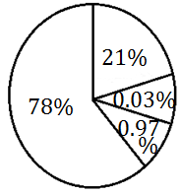44. ***The pie chart below shows amount of gases in the atmosphere. use it to answer questions which follow***.

(a) Name the gas represented with the total percentage of 21% in the pie chart.

________________________________________________________________________

(b) Which gas occupies the largest part in the atmosphere?

________________________________________________________________________

(c) Give two uses of carbon dioxide in the environment.

(i) ____________________________________________________________

(ii) ____________________________________________________________

45. (a) Name two components of blood.

(i) _______________________________________________________

(ii) _______________________________________________________

(b) Give one structural difference between a vein and an artery.

________________________________________________________________________

________________________________________________________________________

(c) Name one disease of circulatory system.

________________________________________________________________________

46. Study the table below and answer the questions that follow.

|  |  |
| --- | --- |
| **List A** | **List B** |
| Tilapia  Frog  Crocodile  Dove | Rat  Goat  Lion  Whale |

(a) What is the similarity in the way animals in list A reproduce?

________________________________________________________________________

________________________________________________________________________

(b) To which class of animals do those in list B belong?

________________________________________________________________________

(c) In which way is tilapia in list A similar to a whale in list B?

________________________________________________________________________

________________________________________________________________________

(d) What is common about animals in list A and B?

________________________________________________________________________

47. (a) Mention two solutes used in making ORS.

(i) ______________________________________________________________

(ii) ______________________________________________________________

(b) How is ORS useful to dehydrated person?

________________________________________________________________________

(c) Apart from ORS, what else should be given to the patient with severe diarrhea?

________________________________________________________________________

48. (a) What is germination?

________________________________________________________________________

________________________________________________________________________

(b) Name the three conditions necessary for seed germination.

(i) ____________________________________________________________________

(ii) ____________________________________________________________________

(iii) __________________________________________________________________

49. ***The diagram below is of a bird’s egg. Use it to answer the questions that follow.***

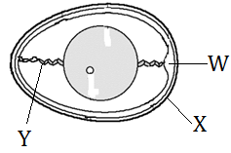

(a) Name the part marked W.

________________________________________________________________________

(b) State the function of part marked Y.

________________________________________________________________________

(c) Why is part labeled “X” porous?

________________________________________________________________________

(d) Explain why an egg may fail to hatch.

________________________________________________________________________

50. ***Study the diagram below and use it to answer questions that follow***.

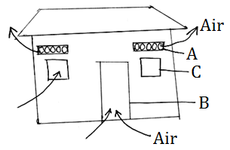

(a) Name the structure marked A on the diagram above.

________________________________________________________________________

(b) How are structures marked B and A important?

(i) B ___________________________________________________________________

(ii) A __________________________________________________________________

(c) How can you improve the sanitation of the above house?

________________________________________________________________________

51. (a) Write DPT in full.

________________________________________________________________________

(b) Why is DPT vaccine called a triple vaccine?

________________________________________________________________________

(c) Name any two diseases prevented using DPT.

(i) __________________________________________________________________

(ii) __________________________________________________________________

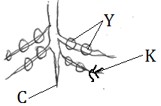52. ***The diagram below shows a root of a bean plant. Use it too answer questions that follow***.

(a) Name the root system above.

________________________________________________________________________

(b) How are the following parts useful to the plant?

(i) Y __________________________________________________________________

(ii) K __________________________________________________________________

(iii) C __________________________________________________________________

53. ***Below are different types of blood calls. Use them to answer questions that follow***.

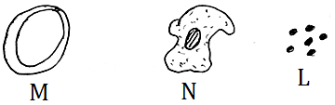

(a) Name the type of blood cell marked L.

________________________________________________________________________

(b) How important is blood cell marked M in the body?

________________________________________________________________________

________________________________________________________________________

(c) Which of the above marked cells is infected by germs spread by female anopheles mosquito?

________________________________________________________________________

(d) Where in the body are blood cells of type N produced?

________________________________________________________________________

54. (a) Give any two method of making alcohol.

(i) ____________________________________________________________________

(ii) ____________________________________________________________________

(b) State the use of water during making of alcohol.

________________________________________________________________________

(c) Why do people take alcohol?

________________________________________________________________________

________________________________________________________________________

55. (a) What is mulching?

________________________________________________________________________

________________________________________________________________________

(b) Write two advantages of mulching.

(i) _______________________________________________________________

(ii) _______________________________________________________________

(c) How does mulching improve soil fertility?

________________________________________________________________________

________________________________________________________________________

**END**